

**FACULTY OF INFORMATION AND COMMUNICATION TECHNOLOGIES**

**FALL 2023**

**CA EXAMINATION**

**Assignment – CA – groups of 3 students**

NDE HURICH DILAN [nde.dilan@ictuniversity.edu.cm](mailto:nde.dilan@ictuniversity.edu.cm) ICTU20223351

NGANA NOA JUNIOR FREDERIC ABEL

[ngana.fredericabel@ictuniversity.edu.cm](mailto:ngana.fredericabel@ictuniversity.edu.cm)

ICTU20223538

Mapa Tetong Caline Staelle

[mapatetong.staelle@ictuniversity.edu.cm](mailto:mapatetong.staelle@ictuniversity.edu.cm)

ICTU20223062

1. **Gather the necessary requirements from the stakeholders**

**1. Validate Document (Done by the Department Officer):**

* **User Requirements:**
  + **The department officer should be able to initiate document validation.**
  + **The system should highlight errors or invalid information.**
  + **A notification should be sent to the user if validation fails.**

**2. Produce an Online Version of the Validated Document (Done by the Department Officer):**

* **User Requirements:**
  + **The department officer should have the option to scan a physical document.**
  + **The system should save the scanned file on the cloud.**
  + **Access to the online version should be restricted to authorized personnel.**

**3. View Document After Submission (Including Editing/Changing):**

* **User Requirements:**
  + **Users should be able to view their submitted documents.**
  + **Editing rights should be granted based on specific criteria.**
  + **Changes made to the document should be recorded for auditing purposes.**

**4. Grant Access (Done by the Department Officer After Checking Reason):**

* **User Requirements:**
  + **Users should be able to request access to edit a document.**
  + **The department officer should review the reason for access.**
  + **Granting or denying access should be accompanied by a notification to the user.**

**5. Organize Documents by Faculty, Department, Instructor, and Other Criteria (Done by the Department Officer):**

* **User Requirements:**
  + **The department officer should be able to organize documents using various criteria.**
  + **Filtering and sorting options should be provided.**
  + **The system should allow for the creation of custom organization schemes.**

**6. View All Submitted Documents (Done by the Department Officer):**

* **User Requirements:**
  + **The department officer should have access to a list of all submitted documents.**
  + **The list should provide relevant details for each document.**
  + **Access should be secure and restricted to authorized personnel.**

**7. View All Validated Documents and Print a List (Done by the Department Officer):**

* **User Requirements:**
  + **The department officer should have access to a list of all validated documents.**
  + **The list should be printable for record-keeping purposes.**
  + **The information presented should include document details and validation status.**

**8. Send Emails to Users Whose Documents Have Been Accepted (Done by the Department Officer):**

* **User Requirements:**
  + **The department officer should be able to send notifications to users whose documents have been accepted.**
  + **The notification should include access to the list of validated documents.**

**9. Admin (University Ambassador) Collects Validated Documents and Submits to Another University:**

* **User Requirements:**
  + **The admin (university ambassador) should be able to access all validated documents.**
  + **The system should facilitate the collection of validated documents for submission.**
  + **A confirmation mechanism should be in place after submission.**

**Common Requirements Across Use Cases:**

* **Security:**
  + **Access to sensitive information should be secure and role-based.**
  + **User authentication and authorization mechanisms should be implemented.**
* **Audit Trail:**
  + **Changes to documents, validation status, and access grants should be logged for auditing.**
* **Usability:**
  + **The user interface should be intuitive and user-friendly.**
  + **Necessary training materials or guides should be provided.**
* **Integration:**
  + **The system should be capable of integrating with scanning tools for document digitization.**
  + **Email notifications should be integrated seamlessly.**
* **Performance:**
  + **The system should handle a reasonable volume of documents without significant performance issues.**
* **Compliance:**
  + **The system should comply with data protection regulations and university policies.**

1. **Design the use case diagram of the project**

**On the next page you will find the screenshot of our Use Case description Diagram followed by the Use cases descriptions**

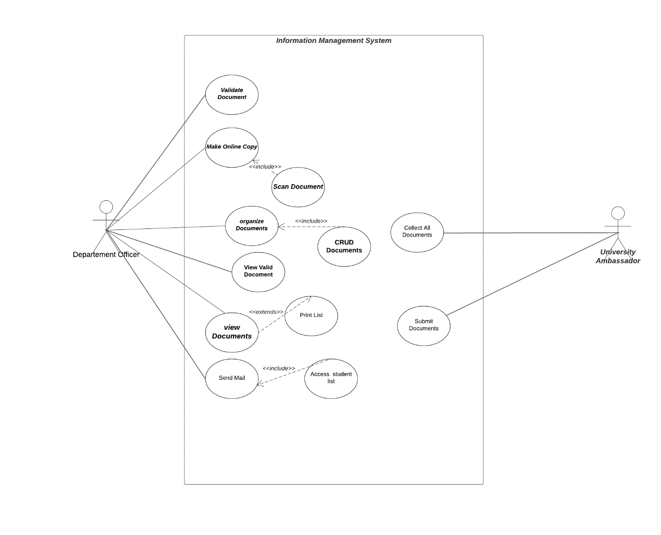

**3. For each use case, write the use case description**

**Use Case 1: Validate Document (done by the department officer)**

1. **Use Case Name: Validate Document**
2. **Summary: The department officer validates submitted documents by checking for errors or non-valid information.**
3. **Dependency: None**
4. **Actors: Department Officer**
5. **Preconditions: The document must be submitted for validation.**
6. **Description of Main Sequence:**
   * **The department officer reviews the submitted document.**
   * **Checks for errors or non-valid information.**
   * **Marks the document as validated if it meets the criteria.**
7. **Description of Alternative Sequence: If errors are found, the department officer communicates the issues to the user for correction.**
8. **Non functional Requirements: Efficient processing time, accurate validation.**
9. **Outstanding Questions: How to handle invalid documents?**

**Use Case 2: Produce an Online Version of the Validated Document (done by the department officer)**

1. **Use Case Name: Produce Online Version of Validated Document**
2. **Summary: The department officer scans the validated physical document and saves the scanned file on the cloud.**
3. **Dependency: Document must be validated.**
4. **Actors: Department Officer**
5. **Preconditions: The document must be validated.**
6. **Description of Main Sequence:**
   * **The department officer scans the validated document.**
   * **Saves the scanned file on the cloud.**
7. **Description of Alternative Sequence: None**
8. **Non functional Requirements: Secure cloud storage, efficient scanning process.**
9. **Outstanding Questions: What cloud storage system will be used?**

**Use Case 3: View Document After Submission**

1. **Use Case Name: View Document After Submission**
2. **Summary: Users can view submitted documents and edit/change them if granted the right to do so.**
3. **Dependency: Document must be submitted.**
4. **Actors: User**
5. **Preconditions: The document must be submitted.**
6. **Description of Main Sequence:**
   * **Users access the system and locate their submitted document.**
   * **View the document details.**
   * **Edit/Change the document if granted permission.**
7. **Description of Alternative Sequence: If no permission is granted, the user can only view the document.**
8. **Non functional Requirements: User-friendly interface, secure editing permissions.**
9. **Outstanding Questions: How is permission granted for editing?**

**4. Design the application flow chart**

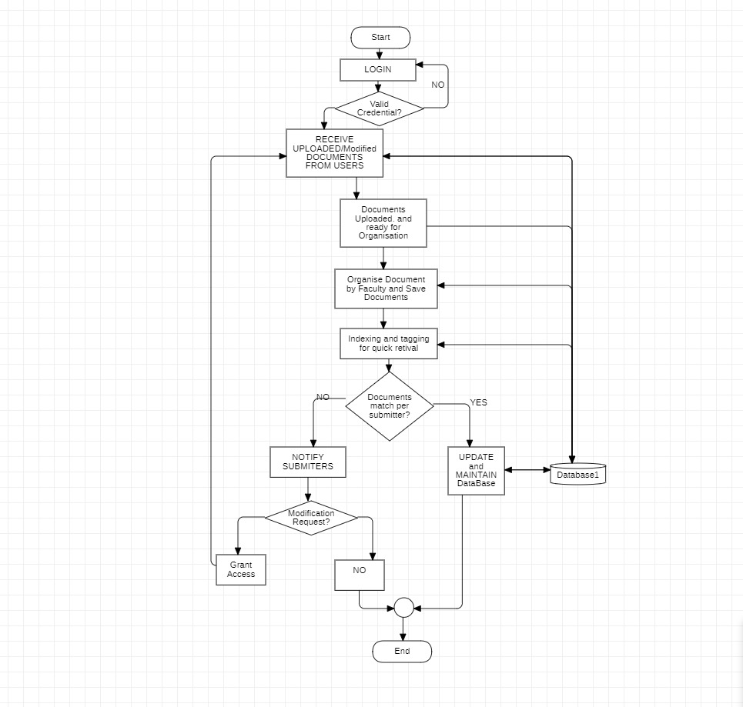

1. Design the class diagram of the application to be developed

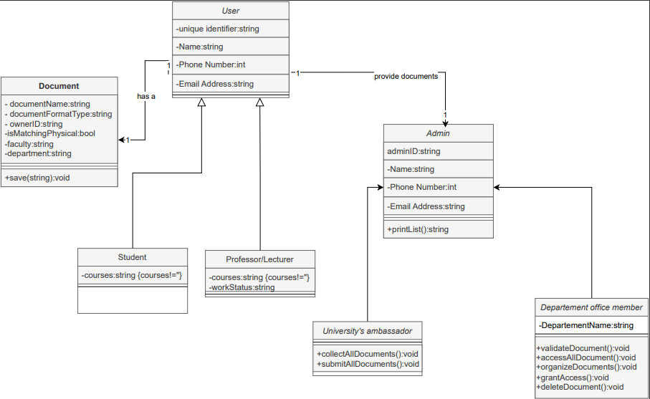

6-Do object structuring and refine the class diagram with design principles and 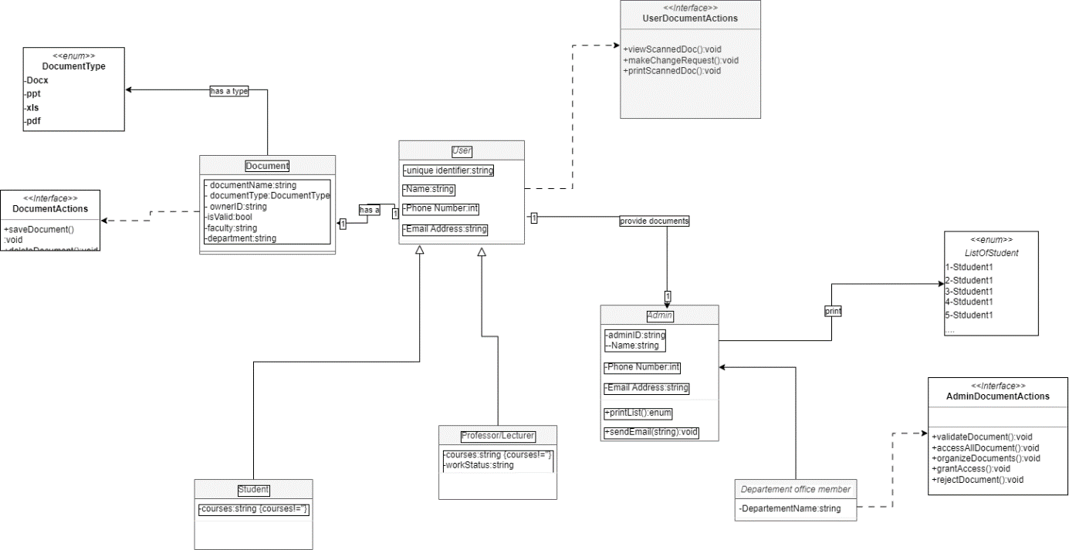

7. Refine the class diagram with the use of design patterns



8-Design the sequence diagram for the use cases

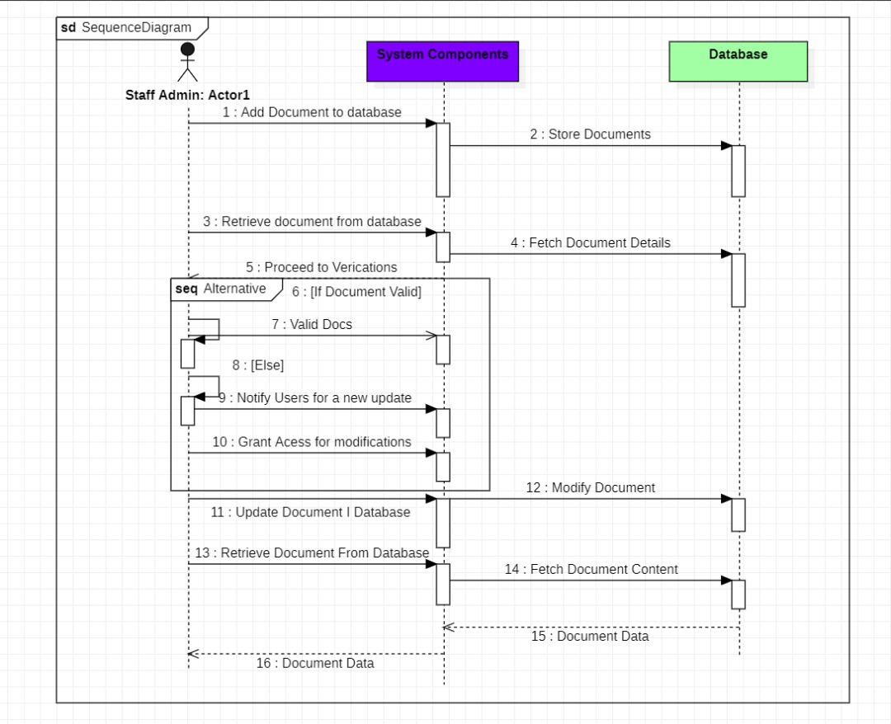

9-Convert the sequence diagram into collaboration diagram

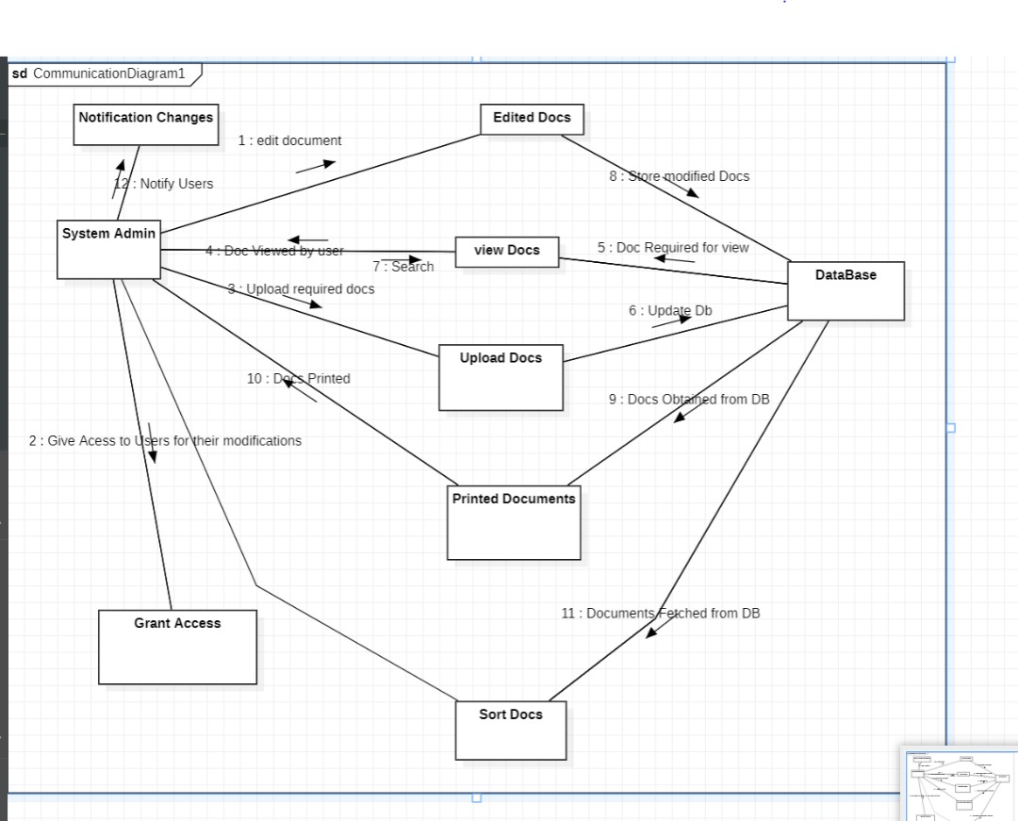

1. Chose three objects from object structuring and design the state transition diagram

